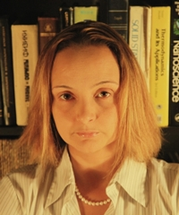

Dr. Starovoitova is a nuclear physicist and the Head of the Applied Physics Group at Niowave, Inc., the only company worldwide that delivers and commissions complete superconducting accelerator systems for national laboratories and private businesses. Dr. Starovoitova's work is focused on the uses of electron linacs, including radioisotope production, active interrogation, and sterilization.

