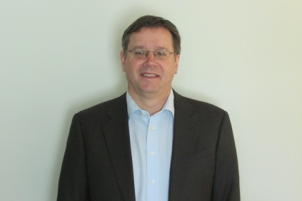

Shane received his doctorate from Oxford University in 1987 for space charge studies on the ISIS synchrotron at RAL, UK.
Subsequently, he moved to TRIUMF and worked on KAON factory designs, the ISAC RFQ, the JPARC RCS and Main Ring, longitudinal dynamics and LLRF of the CERN PSB, FFAGs for muon acceleration, etc. Most recently, he is the project leader for the TRIUMF ARIEL e-linac.

