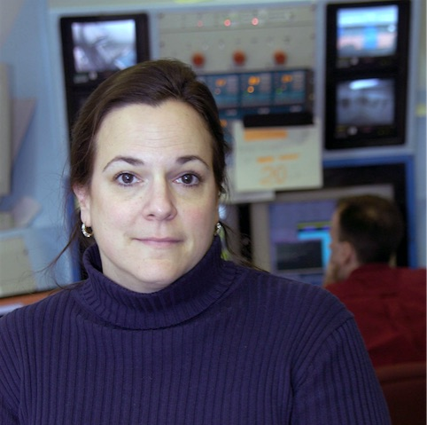
Cynthia Keppel is the Hall A and C Group Leader at the Thomas Jefferson National Accelerator Facility (JLab), and a spokesperson for twelve JLab electron scattering experiments focusing on quark-hadron duality, precision longitudinal/transverse separation experiments, and nucleon and meson structure in particular at large parton momentum fraction. She is co-Spokesperson of the Coordinated Theoretical-Experimental Project on QCD (CTEQ), and currently serves on the National Nuclear Science Advisory Committee. Dr. Keppel holds nine patents for nuclear medicine and radiation therapy technologies, and served as the Senior Executive Director of the Hampton University (HU) Proton Therapy Institute, while holding a joint position as University Endowed Professor of Physics at HU and Staff Scientist at JLab. She received her Ph.D. in 1995 from the American University for research at the Stanford Linear Accelerator Center. She was given the 2016 George B. Pegram Award, a 2011 Virginia Outstanding Scientist Award, and a National Science Foundation CAREER award. She has served on numerous national and international committees, including the National Insitututes of Health National Research Resources Council and the American Physical Society Division of Nuclear Physics Executive Committee. She served as Director of the Hampton University Graduate Studies (HUGS) at Jefferson Lab Summer School for a decade and currently serves as Chair of the National Nuclear Physics Summer School Committee. She is an author of over 180 peer-reviewed publications, including three invited review articles. She is currently working on a fouth, entitled “Hadron Beam Therapy”.

